Git open source version control

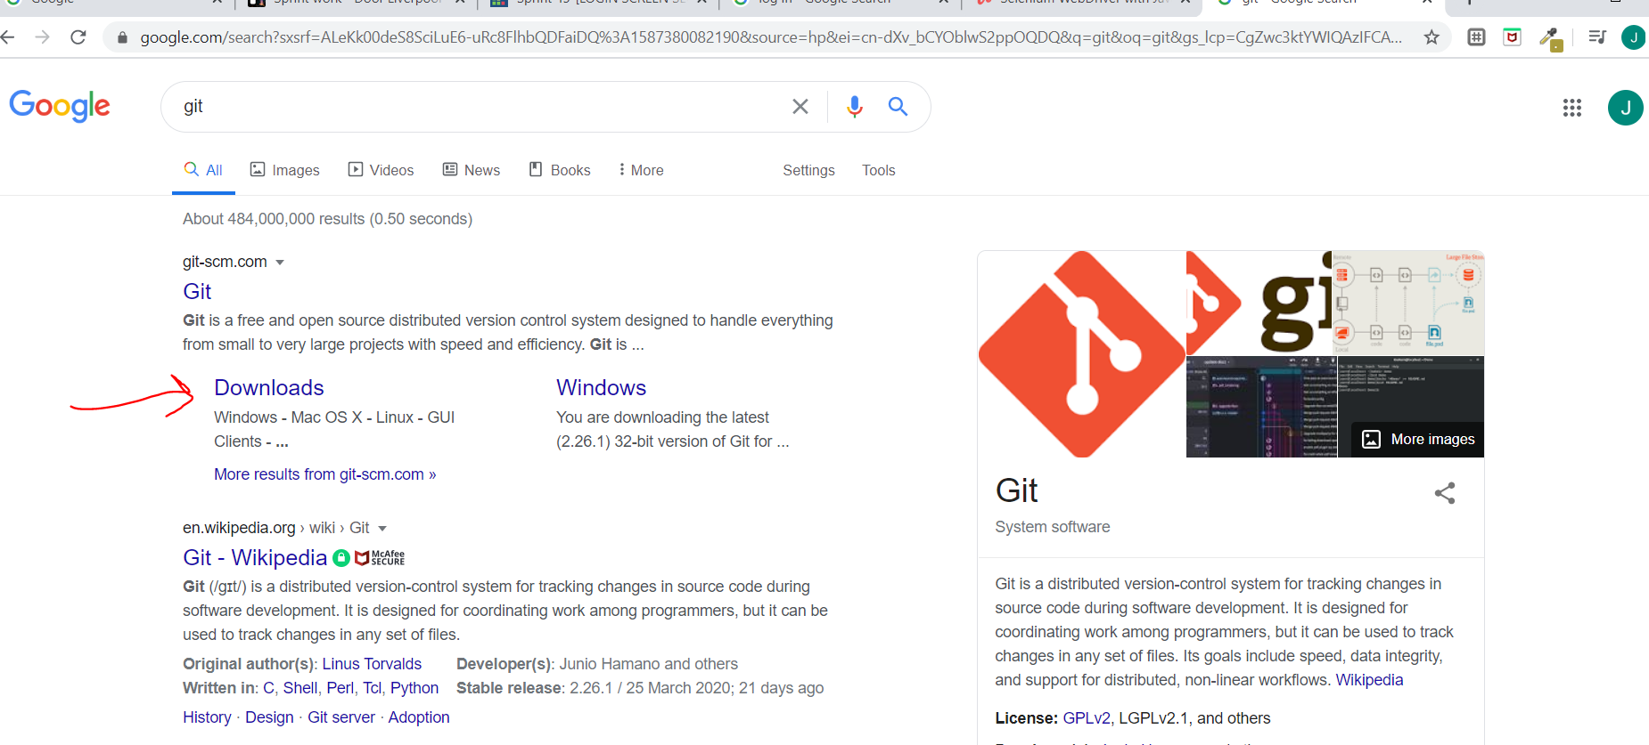

We need to have a 30 mins meeting with paul maddock to discuss how a website testcase how do we combine them all and how are customers able to access it how does dockers and kubernate and terraform come in here…jenkins…how much does it cost to run all this services

Once Git is present in your mission the next thing we need is git hub

GITHUB is a central place where you can post your code. This is where we place our repositories and people download it from there.

To talk to the git hub from your local machine, u need to know the git commands

.we will write commands to talk to this git hub which is central repository

So we need git software in our machine and second we need git hub repository access

Now git hub creation

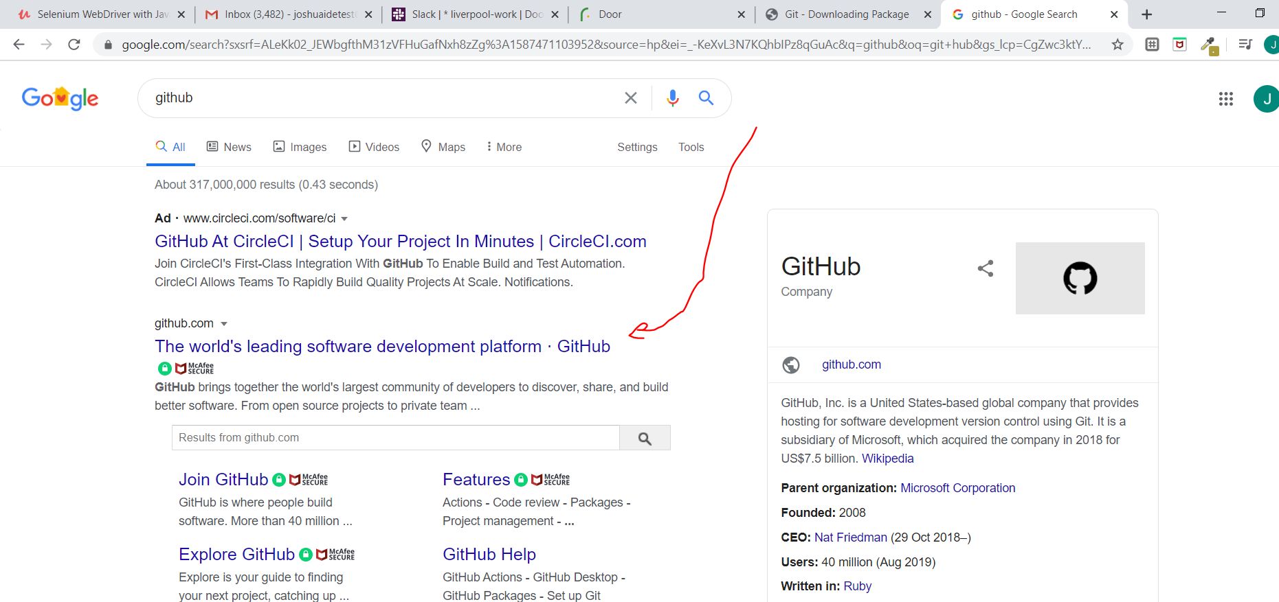

Enreidem Firstborn22\*

Now when you create a user on git and then validate it through email the next step is to create a repository

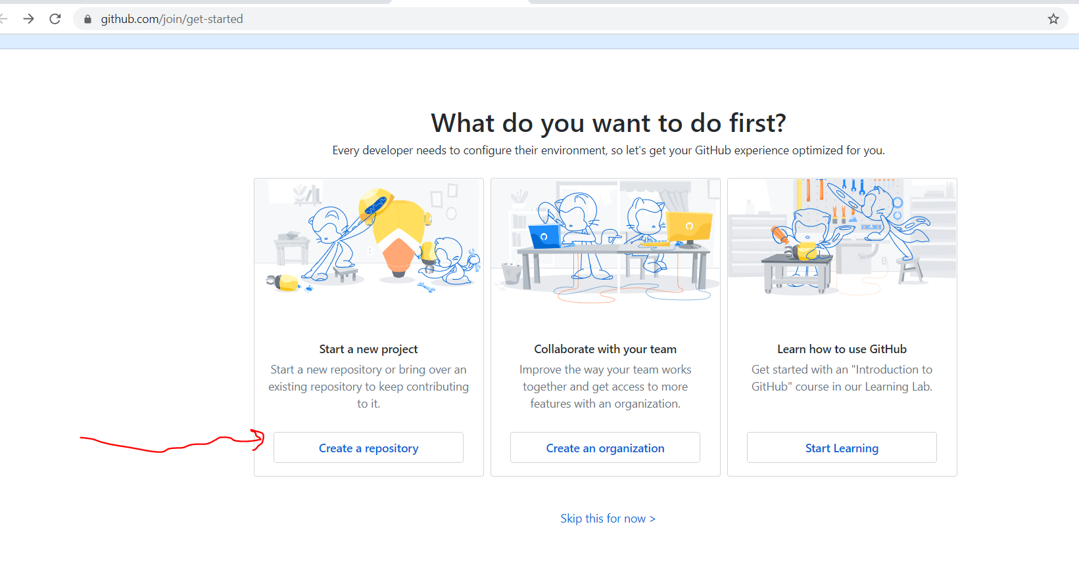

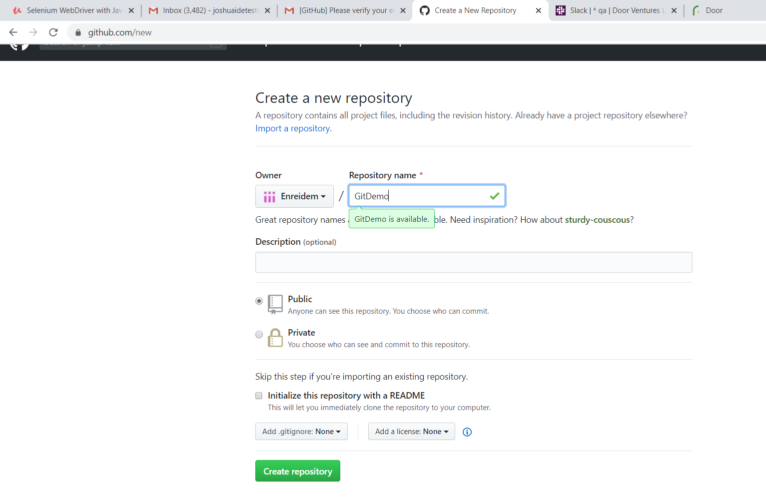

Now next go back to command prompt

Now you need to tell git who you are

Set username Enreidem and email steelblast

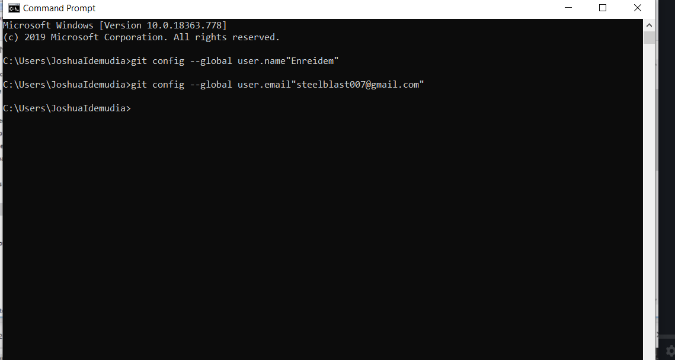

Microsoft Windows [Version 10.0.18363.778]

(c) 2019 Microsoft Corporation. All rights reserved.

C:\Users\JoshuaIdemudia>git config --global user.name"Enreidem"

C:\Users\JoshuaIdemudia>git config --global user.email"steelblast007@gmail.com"

C:\Users\JoshuaIdemudia>

Next lets create a file now in our directory

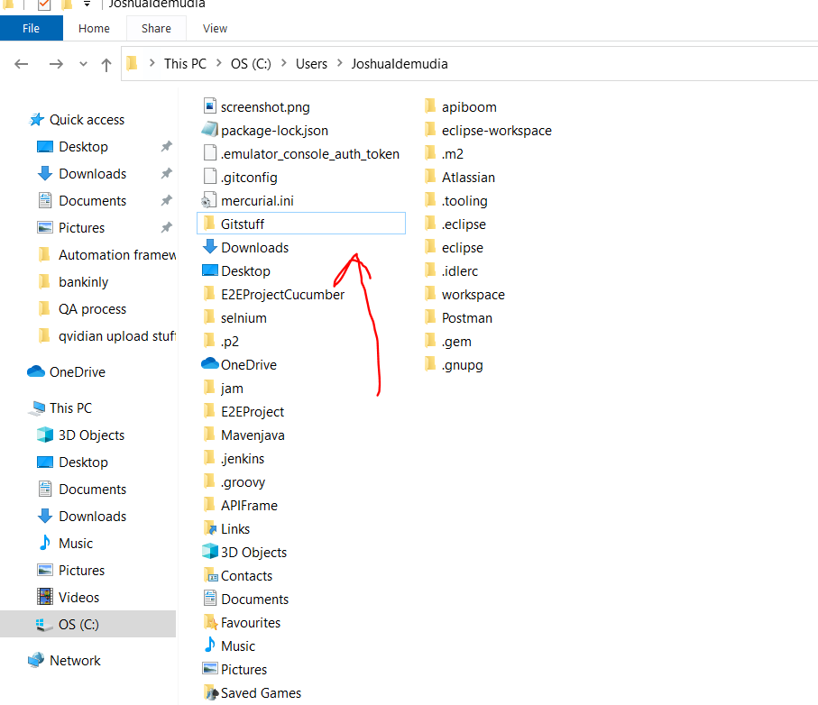

Now move your mavenjava folder into this gitstuff

Go back to cmd and get place the directorty

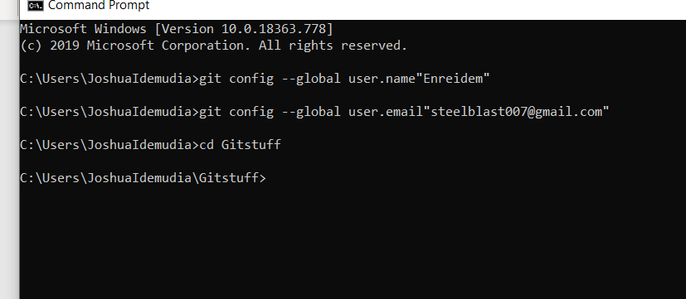

Now once you get to this point u need to give a git command to create a way of talking to your folder

Git init

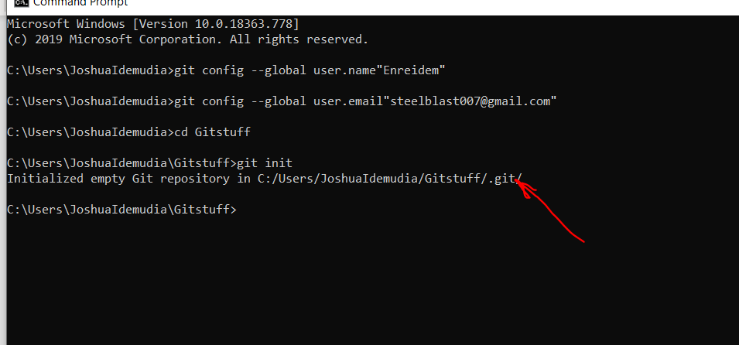

So a git file will be created which is invisible though.

Next step add all your codes to stash …it kind of the first process of committing

This is done by git add \*

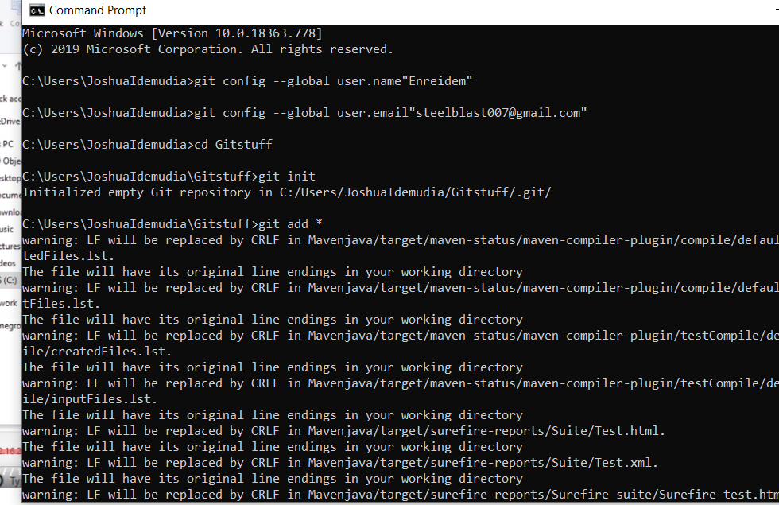

Next we do get status to see what has been added

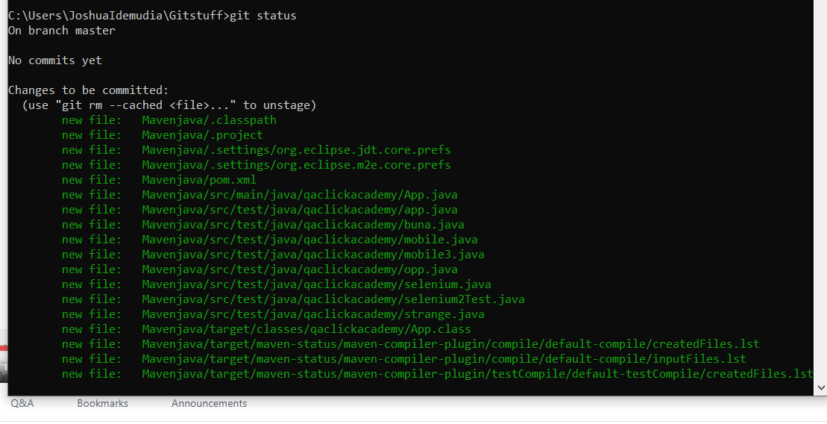

Next commit and always give a message with your commit.

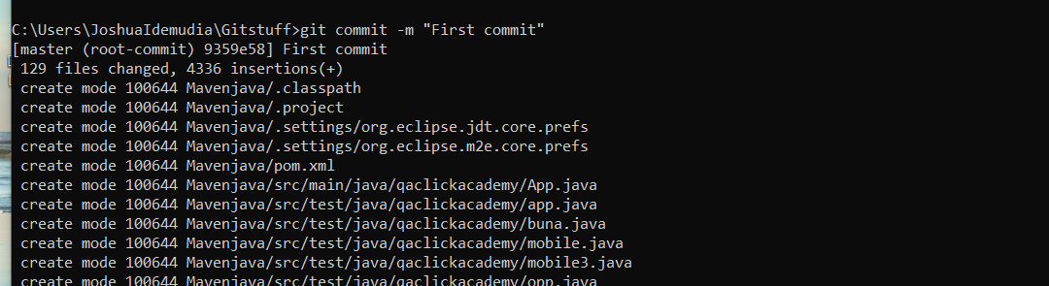

We are now set to move the code to git hub repository…. How cool is that

So staging is git add \*

And commit is git commit -m “First program”

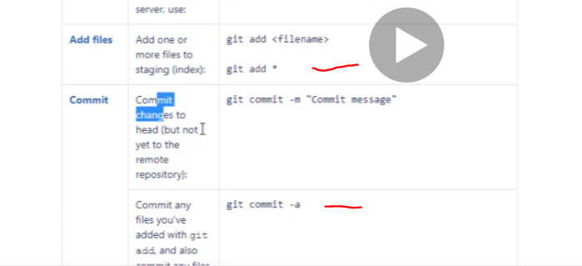

Now next we see how to push the code to git hub

Now before pushing you need to tell your local machine where to push it to

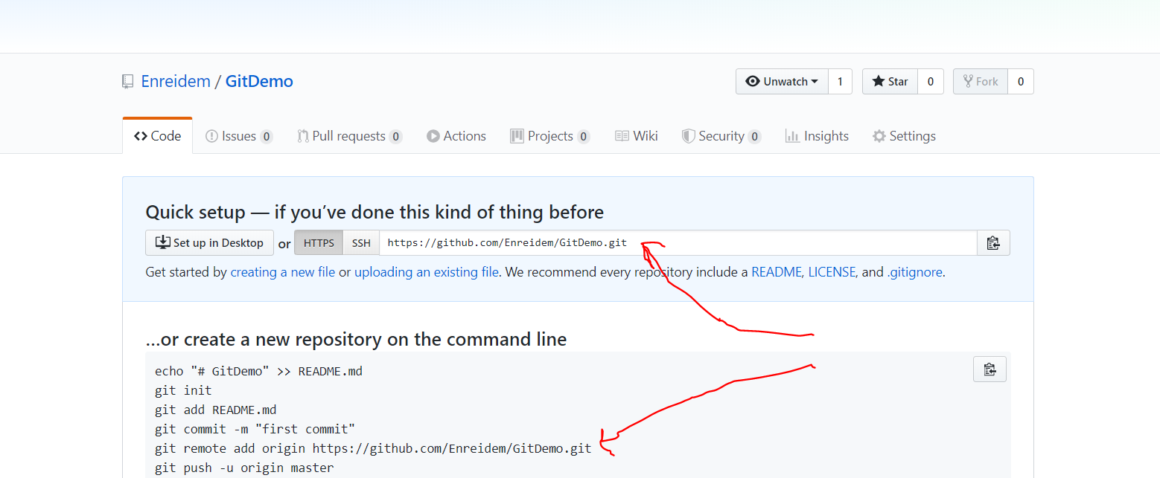

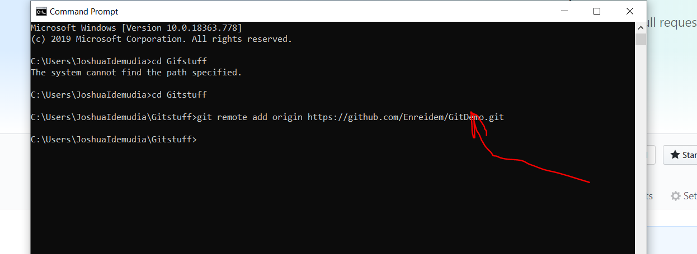

Now your remote repository is connected to your local repository

Now you can push

Note when you create a repository the first branch is the master branch.

Now git push origin master means we are pushing the code to the git remote origin

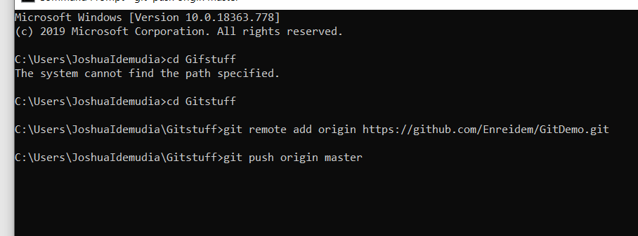

Press enter and user is prompt to log in

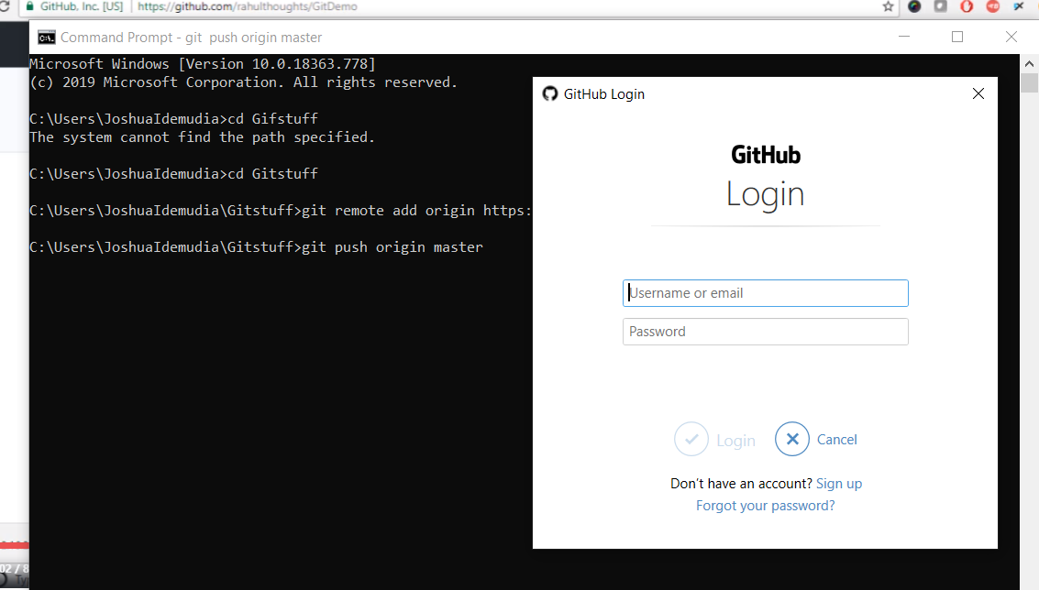

Now you have to give same details you used to create the remote account. By doing this you have connected your local with the remote.

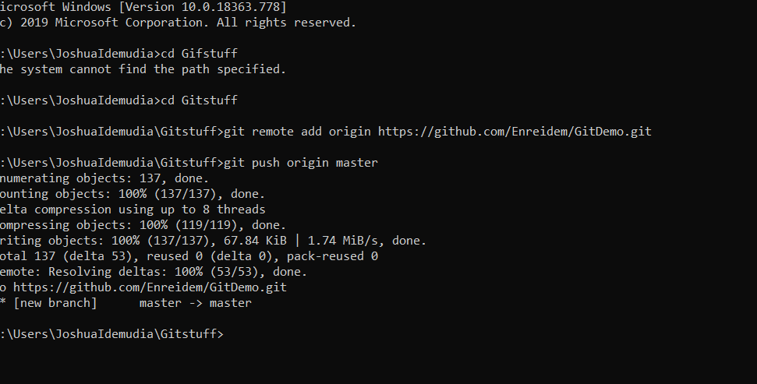

Now it has been pushed

Now go back to the remote git click my name enreidem and if you click repository you will notice

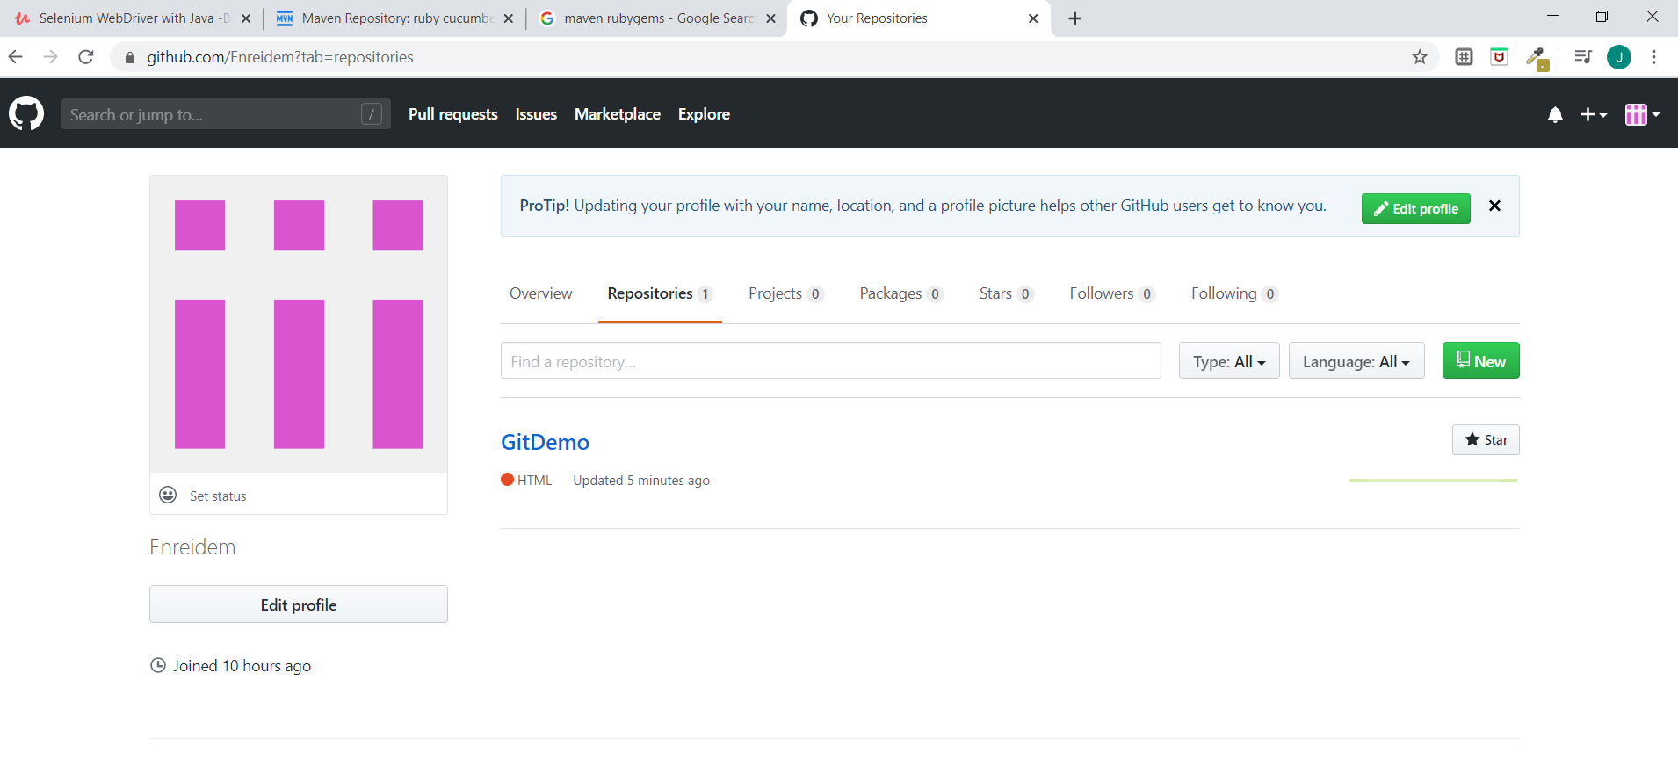

Your company will have their own git repository ask for it and use it.

When you get to your company all that will be set up all u need to do is clone the repository

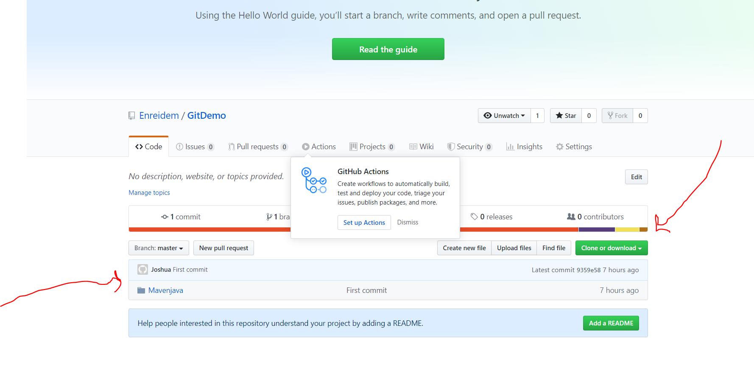

Now next step is to clone the project in another mission

Now clone is done to extract the code present in the repository for the first time.

After the first time then from then on we use pull

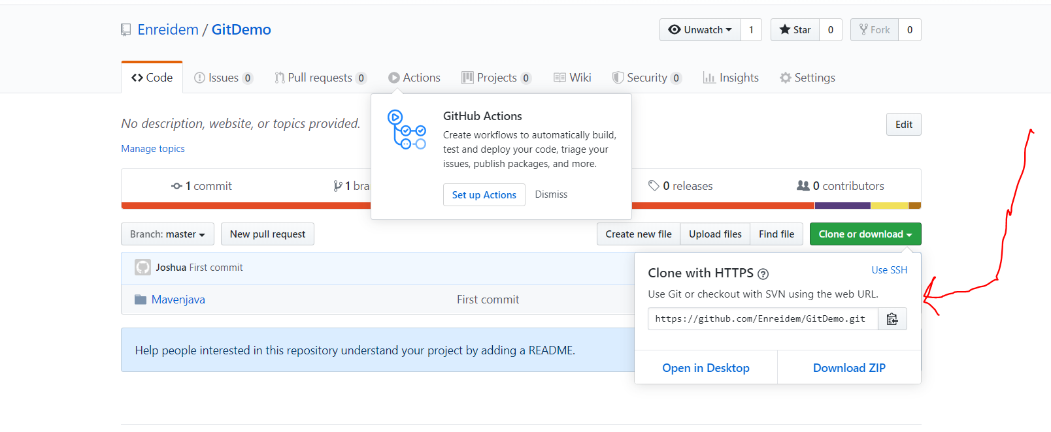

Copy that link, do a cd and paste

C:\Users\JoshuaIdemudia>git clone <https://github.com/Enreidem/GitDemo.git>

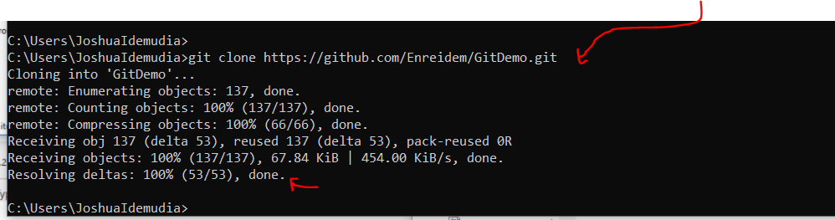

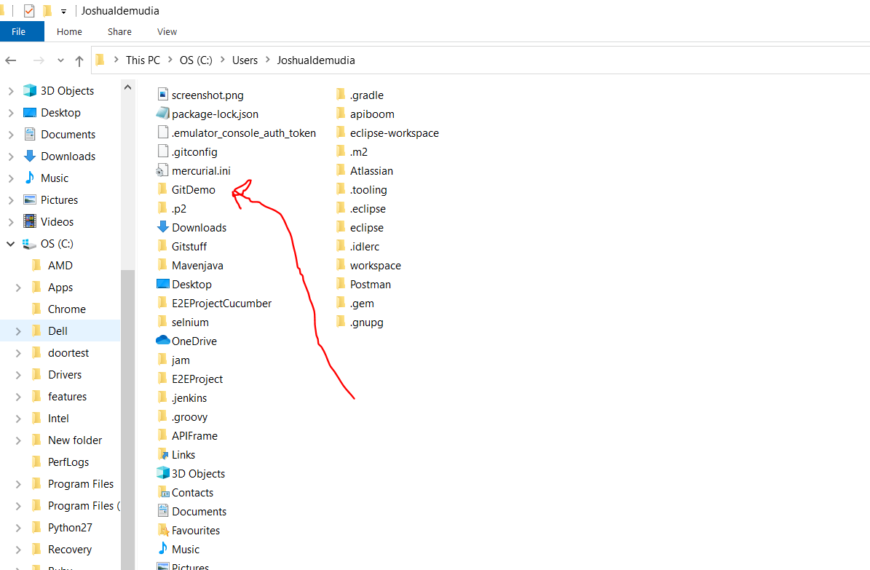

How cool is that. Remember the name of the repository is git demo …. Mr john uploaded things mavenjava to gitstuff then we move gitstuff to the remote then pulled it down for once with clone as you can see…..hahah…how cool it is

Now lets get eclipse into this bitch

File Import general existing projects gitdemo and finish

Now I have downloaded this to my eclipse now if I make changes how do I push it?

First get the actual directive

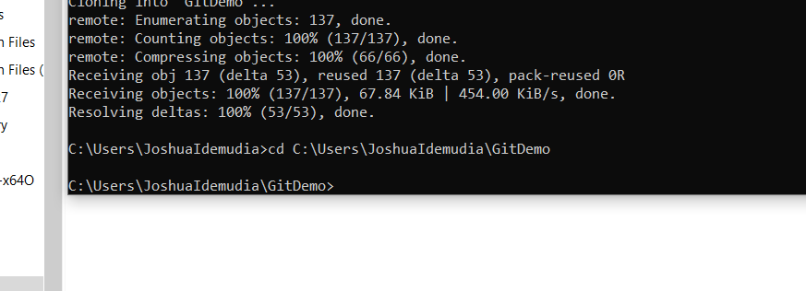

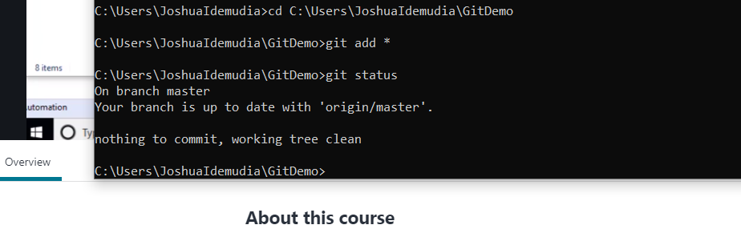

Now if you notice I didn’t make any changes on gitdemo in eclipse so u can see it says no changes have been made.

In this case changes were made

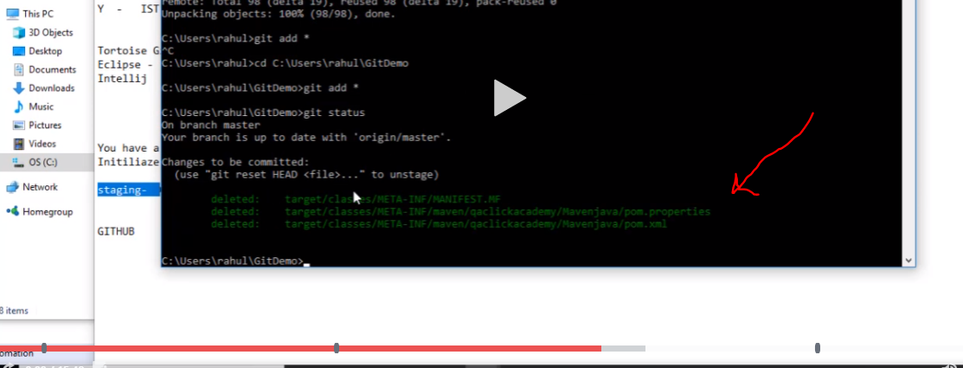

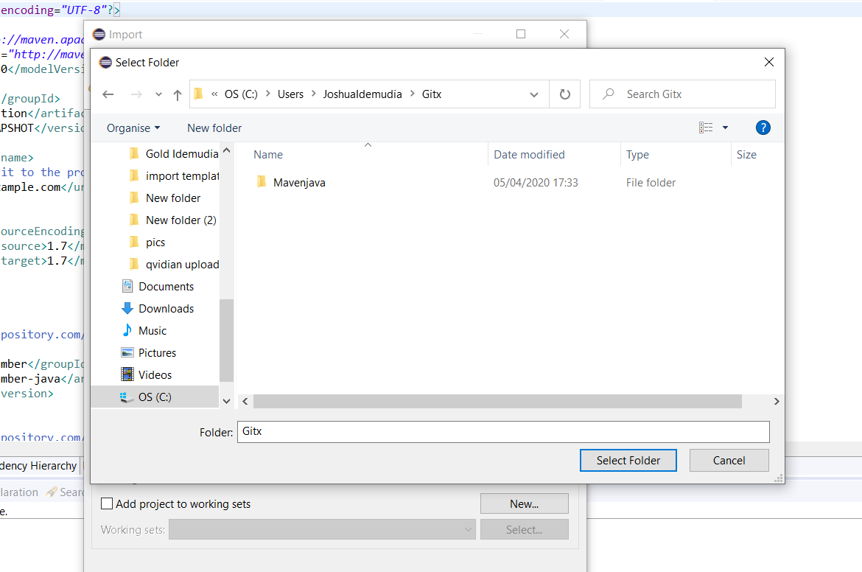

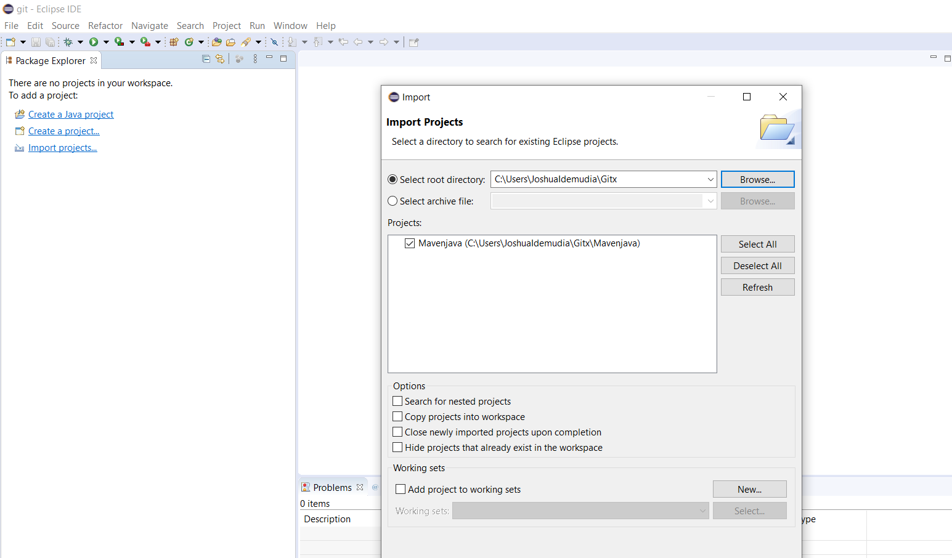

Now do the import with git demo first then do it with gitx

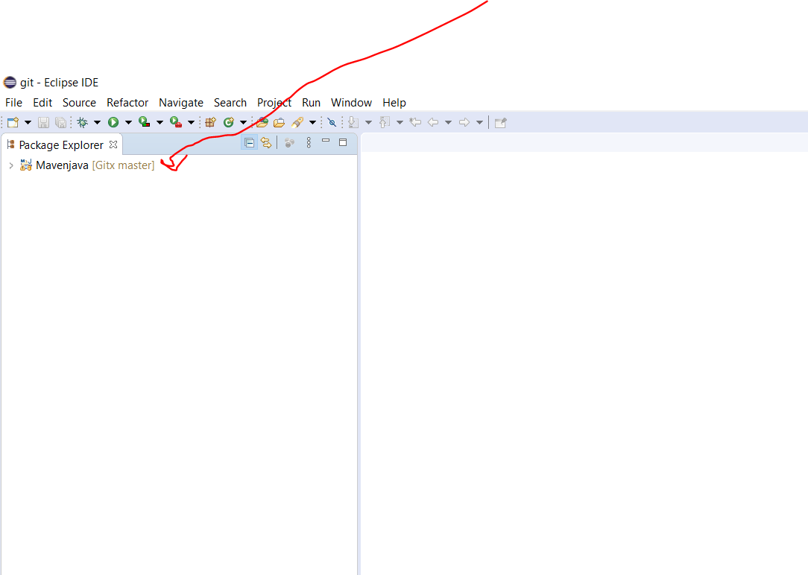

That was it u see that and u know its now a git stuff now lets make changes.

Now we want to commit it remember do this with a message after doing

git add \*

Next check status git status

Then commit git commit -m ”this is from gbala guy”

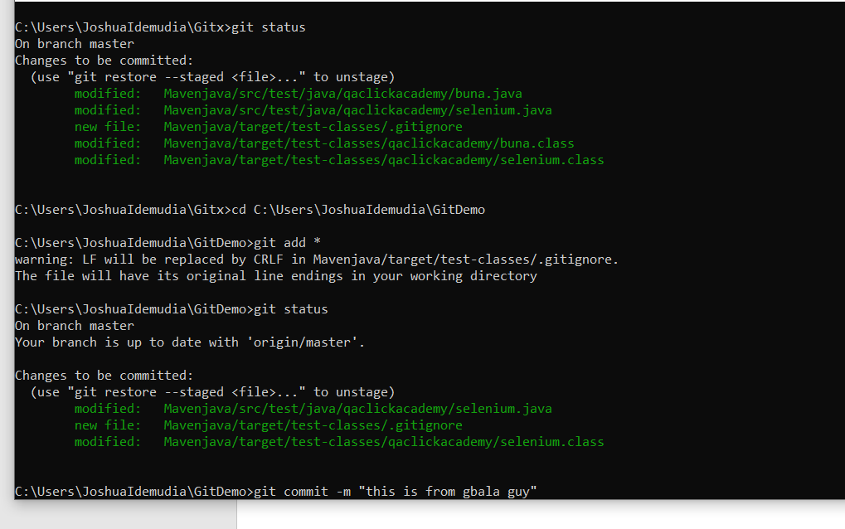

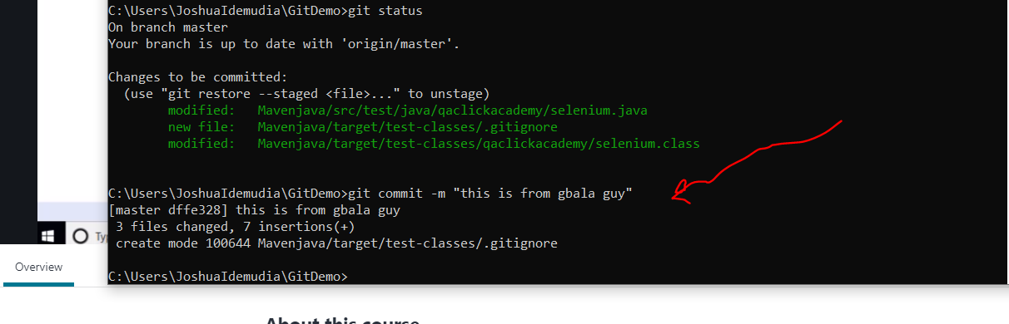

At this point we need to push it

C:\Users\JoshuaIdemudia\GitDemo>git push origin master

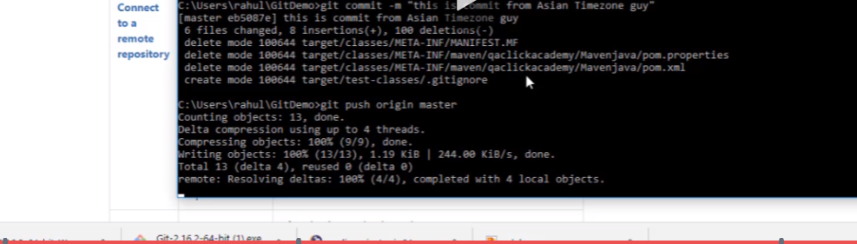

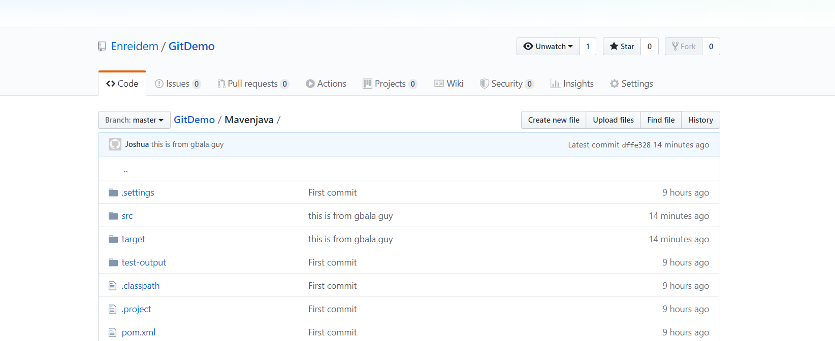

Remember this is from gbala guy so it was sent.

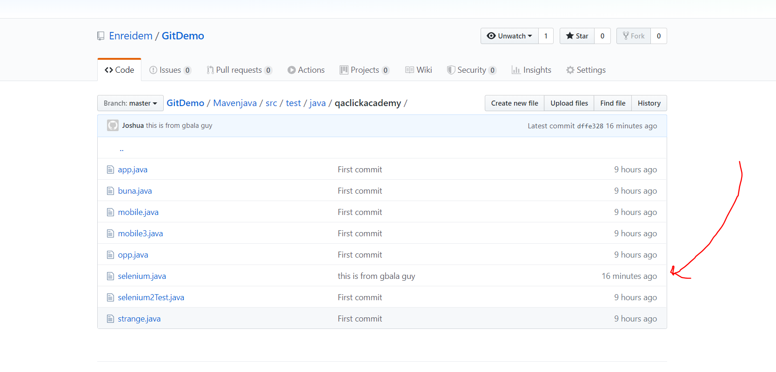

Now the second guy comes into the office and runs gitx with the intention of pulling now first guy pushed second guy pulls

Remember first we created a folder gitstuff and added mavenjava code to it. Then we downloaded git to out system then we created the remote github and saved the repository project as gitdemo

Now we committed the code to the project….. now gitdemo . then we changed gitstuff to gitx….

Now both of them are git masters

So we push and pull

Now we go to the gitx project and want to pull

Remember we have already cloned the repository all we need is just to see updates so we pull to the master

C:\Users\JoshuaIdemudia\Gitx>git pull origin master

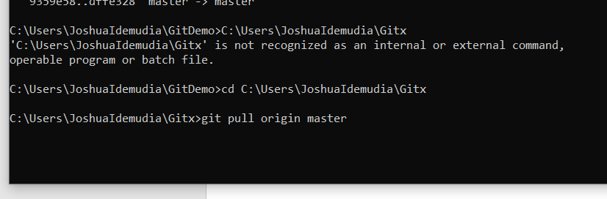

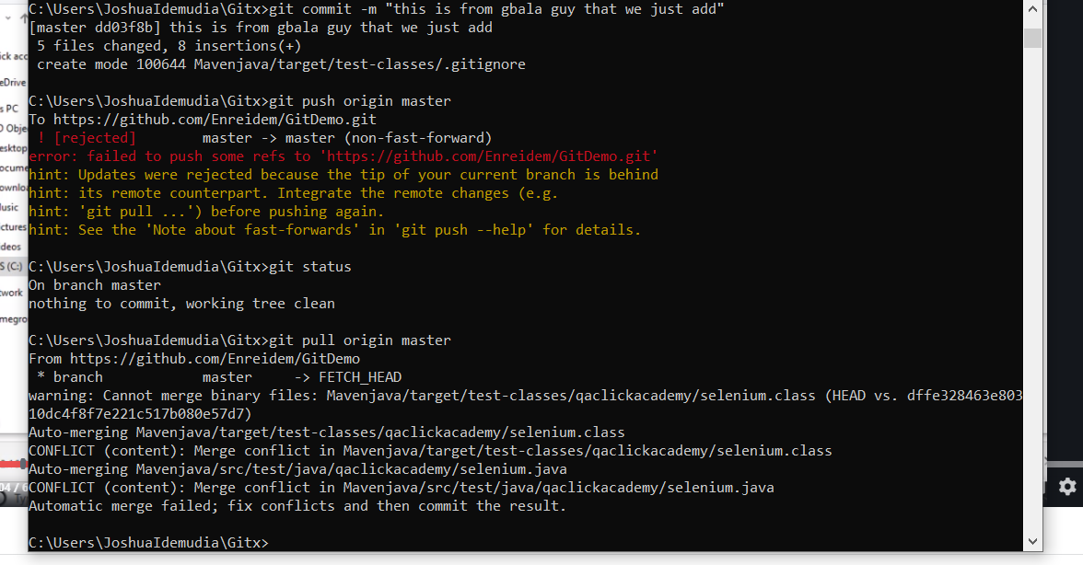

Remember once downloaded the clone all you need to do is to do a pull or push

Advice finish gitdemo first then do gitx

You wnt believe how fucking stupid I am . lost all that work.

branching

When branching the idea is to do another work like a duplicate of the same work but in a different branch

First after cloning the repository and having teo masters the one you sent and the one a user clones the nect thing to have a branch you do

G git checkout -b <name of the new branch>

Now when you do this with the directory of where it is saved and go to eclipse you will notice it shows the name.

After working you can use git add \*

Git status to check

Git branch to see which branch you are on

Git commit -m “put message”

Git push or pull origin master or if the branch name is develop then use that name.

You will notice that your eclipse will show the branch name

To merge be on the directory of the one you want to merge and git merge master or git merge the branch

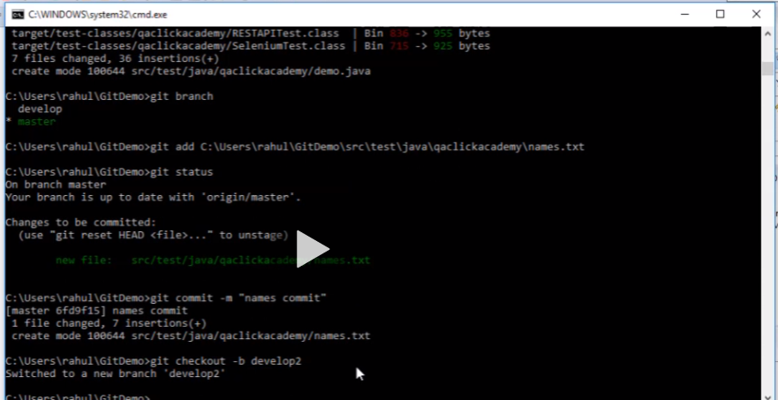

Used to create new branch git checkout develop2

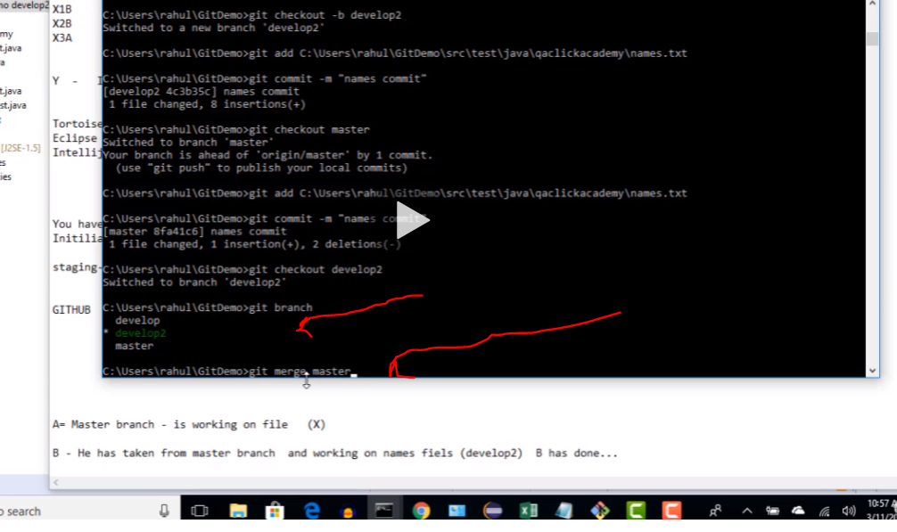

Shows how u know the branch and how to merge branch to master

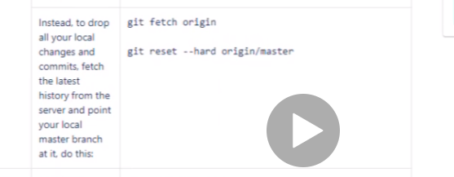

This is used f you want a fresh gitdemo instead of worrying about deleting stuff just start fresh

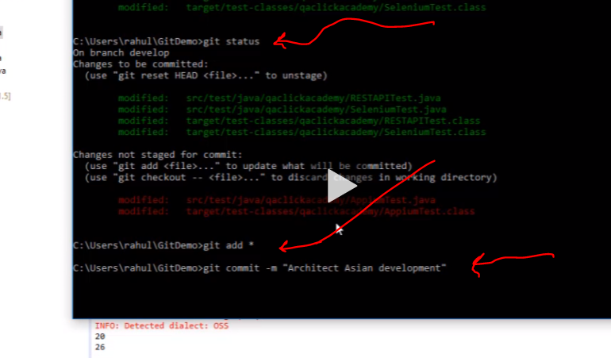

Git add for staging thn commit with message then finally push or pull

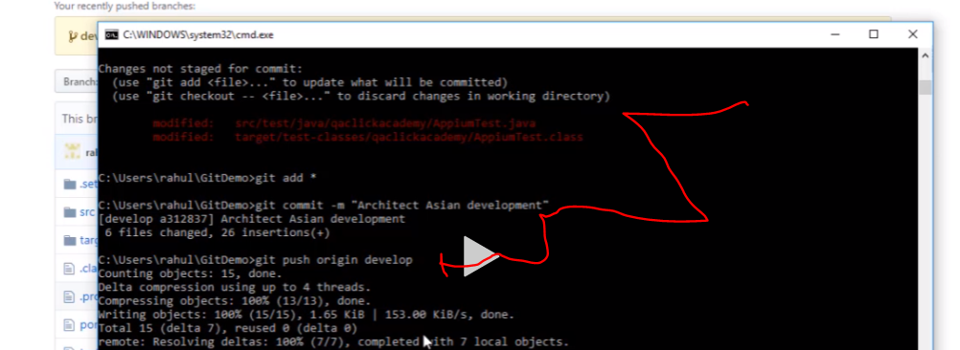

Push

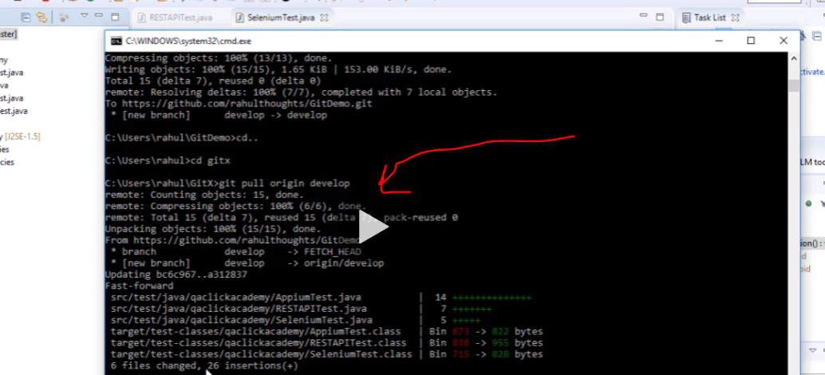

Pull

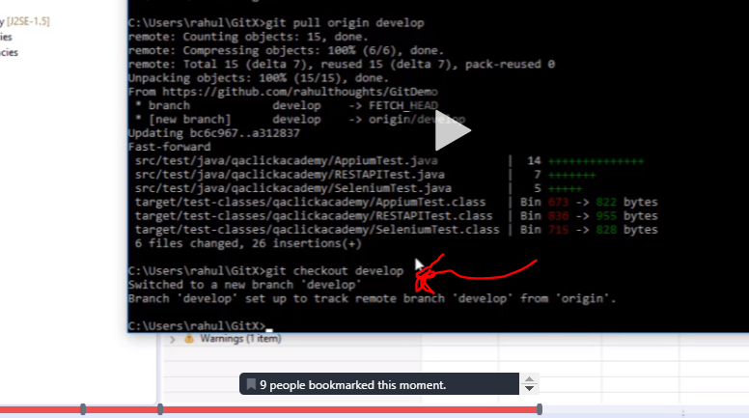

To swich between branch use that command with the name of the branch master or develop

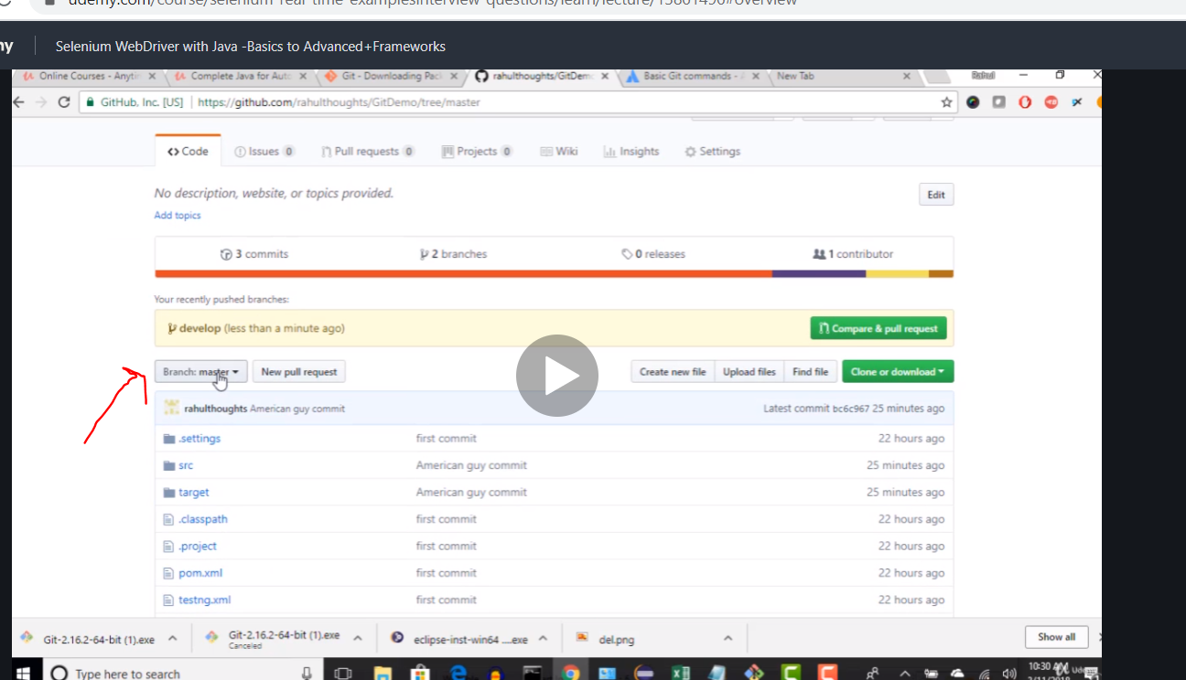

When come back to the remote you will notice the branches and master can all be seen in this dropdown

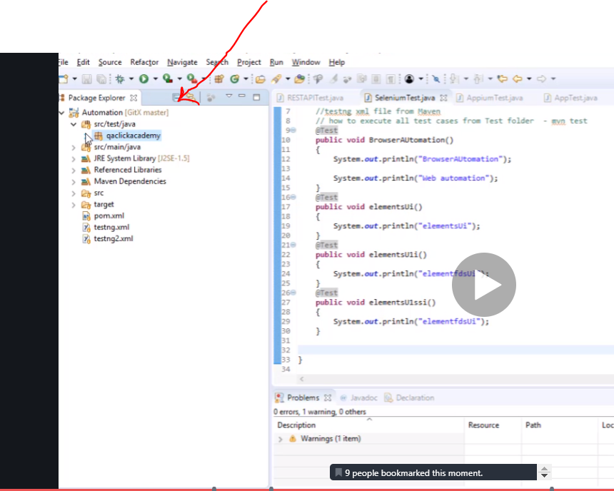

That changes accordingly tobetween your branch and master name.